**Project Design Phase**

**Solution Architecture**

|  |  |
| --- | --- |
| Date | 15 February 2025 |
| Team ID | LTVIP2026TMIDS80646 |
| Project Name | Dog Breed Identification using Transfer Learning (VGG19) with Flask Deployment |
| Maximum Marks | 4 Marks |

**Solution Architecture:**

The Dog Breed Identification System follows a modular, three-tier solution architecture that integrates a web-based user interface with a Flask backend and a deep learning model for real-time image classification.

The architecture ensures:

* **Scalable deployment** (can be extended to cloud environments)
* **Reliable image processing pipeline** (preprocessing and validation)
* **Accurate prediction results** using a transfer learning-based CNN model (VGG19)
* **Clear separation of concerns** between frontend, backend, machine learning, and storage components

The system allows users to upload dog images via a web interface. The Flask backend performs input validation and preprocessing before forwarding the image to the trained VGG19 model for inference. The predicted breed and confidence score are returned to the frontend for display. Model files and uploaded images are managed using local storage, with provision for future cloud storage integration.

**Solution Architecture Diagram:**

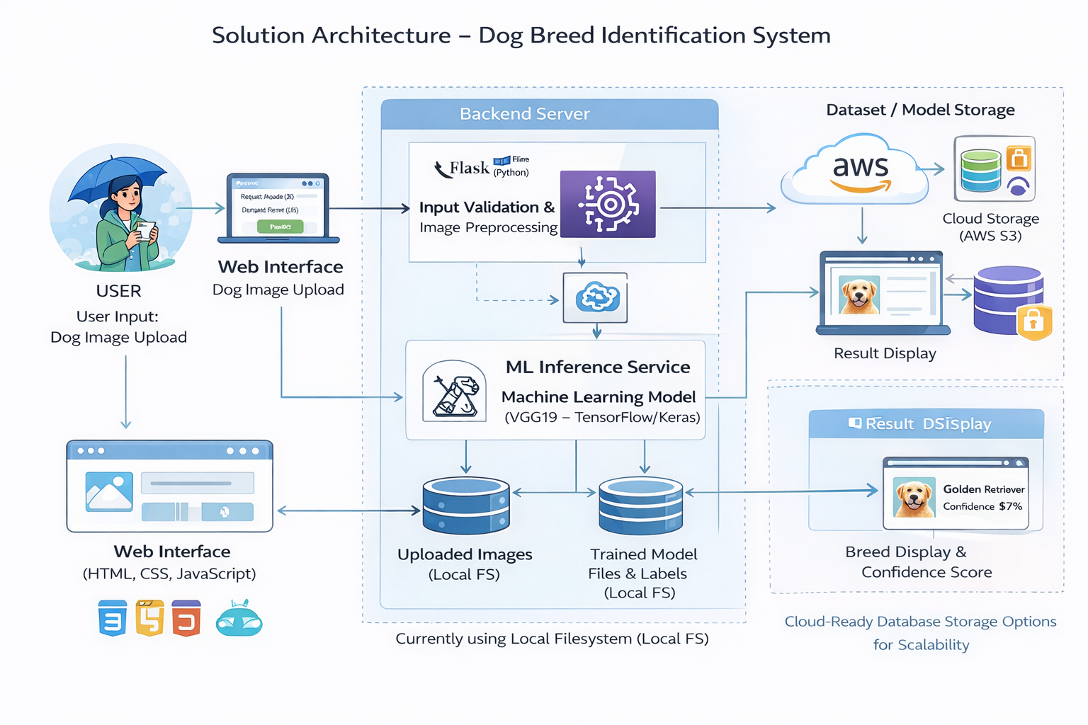

*Figure 1: Solution Architecture and Data Flow of the Dog Breed Identification System*